**Unit 22 System Analysis and Design - Task 2**

**Mohammed Mahin Ibnay Mamun / 346584**

**Investigating the needs of Tameside General Hospital**

**1: Aims and requirements of Tameside General Hospital- (P3)**

As part of Tameside General Hospital's online booking service, the patient can view their upcoming appointments online and book an appointment online. Furthermore, hospital employees can see which appointments are scheduled with which patients and at what time.

In contrast to this, the current system is outdated and has several errors Aswell as failing to meet the user's requirements. Including double bookings of appointments, appointments that cannot be booked showing up on the system, and ghost appointments.

**Aims and Goals:**

**Aims and goals of the current system:** This system provides staff and patients with the capability to manage, view, and book appointments. It also allows you to manage prescriptions, and the delivery of those prescriptions, of your patients.

It is an online system intended to streamline the process of scheduling appointments by enabling the user to view and book appointments securely online, rather than having to make calls to book and view appointments as well as manage prescription delivery.

With a traditional system it is more likely that human errors will occur, such as the misreading of dates or times. The current system reduces human error while managing appointments.

**How did the hospital not meet those aims?** There are a few problems with the hospital's current system since it is designed to make managing, viewing, and booking appointments easier, but the current system is outdated and has many errors that make it impossible to handle prescriptions effectively, as it was designed years ago.

**Why did the system fail?** Due to its outdated nature and many errors and bugs, the current system fails to achieve its goals and aims due to its shortcomings.

**How can the system be improved?** In the new system, errors such as double appointments and appointments being booked randomly can be fixed, which will improve the current system. The software will be updated so that it fixes all bugs and errors within the new system.

In addition to adding the ability to manage prescriptions and deliveries, the system can also be improved by adding a report on prescriptions to be delivered. As a result, patients can get their prescriptions as soon as their appointment is over.

2:How IT is used to support users, staff, and location- (P3)

**Patient’s needs and requirements:** It is imperative that patients can see their upcoming appointments, manage their appointments, and schedule new appointments. Besides managing the patients' prescriptions, the system must also manage their information about their medication, including how to use it and when it will expire.

Patient interactions should be easy to understand and available on a variety of devices, including desktop computers, smartphones, and tablets. A fast and error-free system is also important to the patient. As soon as the patient logs in, they should be able to look at everything and they should not have to wait for information to appear, they are expected to get a fast operation.

**Staff needs and requirements:** Staff members must have access to view, book, and manage patients' appointments. They should have access to book prescriptions for the patients during appointments. It is also necessary for patients to receive messages regarding the appointments booked by the staff over the phone as well through the system.

Moreover, the staff must be able to customize certain parts of the system according to their individual working styles, for example what information they want to display first when they log in.

**Location:** It should be possible for patients to see the location of the hospital and when within the hospital, where their appointments are, they should be able to view a map highlighting where the appointments are.

Creating a requirements specification: (P3)

**Introduction to questionnaire:** Specifically, the questionnaire focuses on the current hospital system and the types of services that patients prefer to receive, as well as whether the existing system could be improved. To identify the current issues that there are and how to improve them, the questionnaire will be filled out by interviewing those who have used the system and those within the hospital system who must use it.

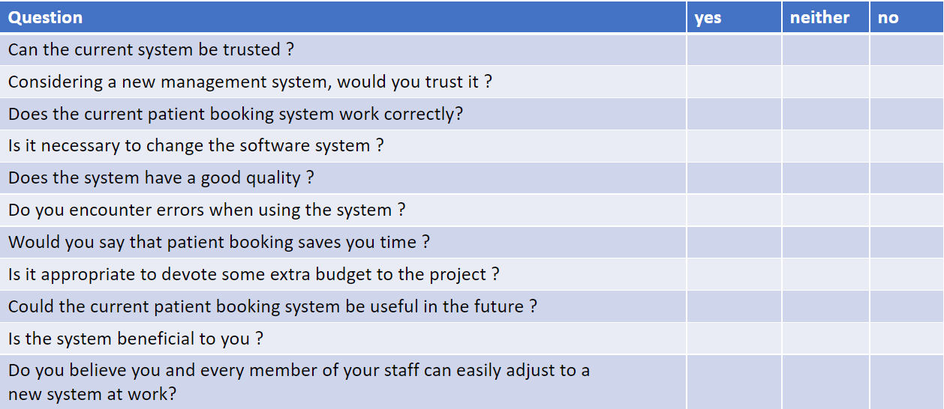

**Confidentiality**: I have created a confidentiality form for the staff at Tameside Hospital to read and sign before they fill out the questionnaire. By doing this they can know what the information they supply will be used for. Below is a screenshot of the from.

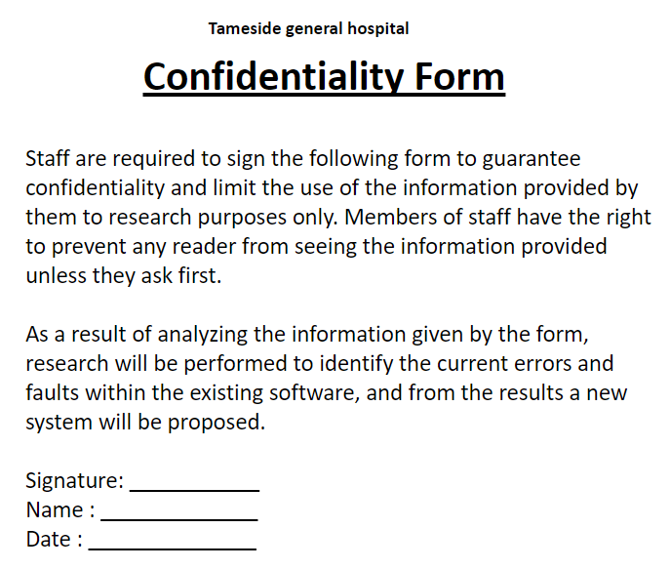

**Feedback:**

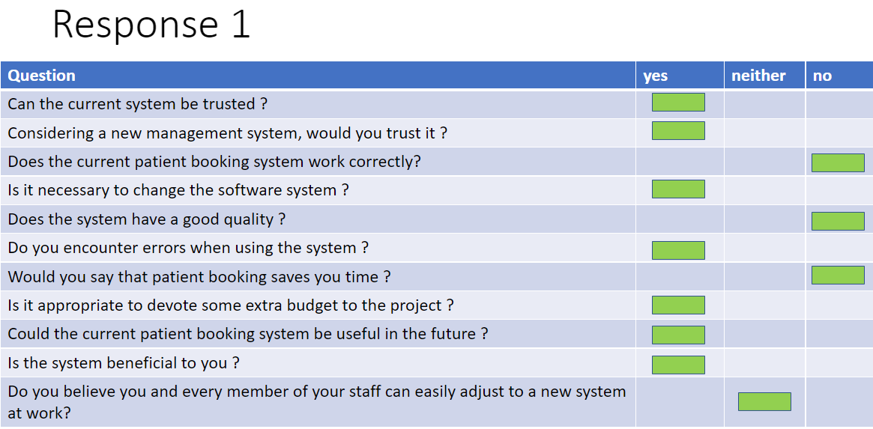

The first reviewer's comments are above. This reviewer answered the questions straightforwardly with a majority of yes and no answers. However, the reviewer answered neither for one question. Overall, this reviewer viewed the system with a more positive than negative perception..

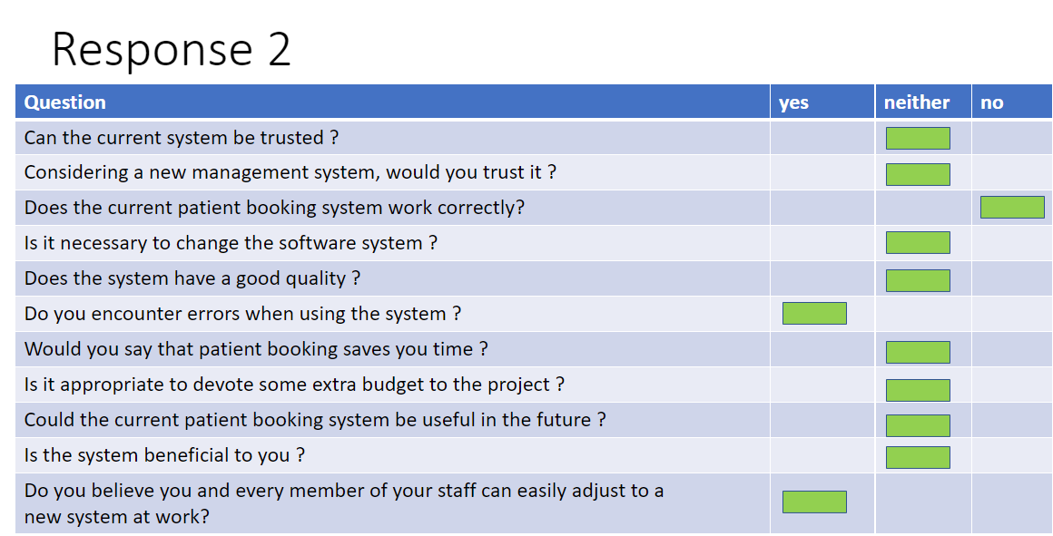

A review said the new system could be easily adjusted by the staff, while the current system had a few flaws. In comparison to the first reviewer, the second person was more in the middle of most of the questions. Additionally, this reviewer said the system was not working correctly as well as the first

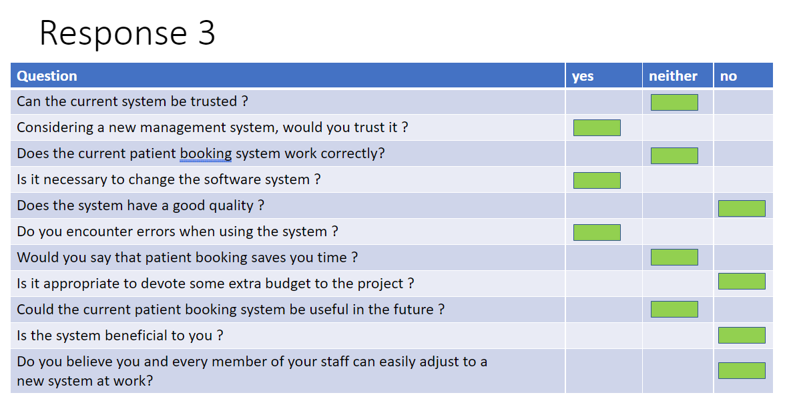

According to the person who discussed the questionnaire, the new system had errors, changes to the system would need to be made, and the system would need a higher budget. While they disagreed with the fact that the system is high quality and has a high budget, they also disagreed with the fact that it is beneficial. Their opinions were not in agreement nor disagreement with the rest of the questions.

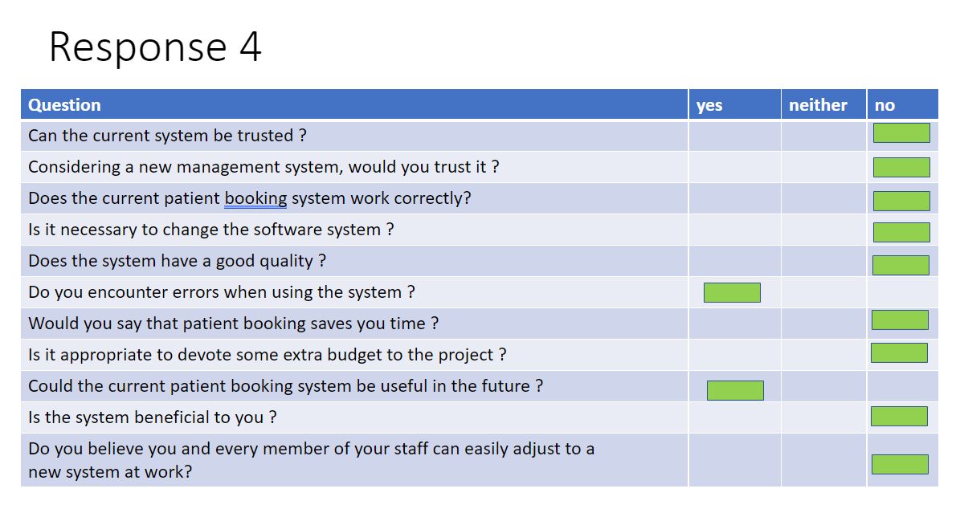

As compared to the others, this reviewer had a highly negative response. Their decision was not based on a 50-50 split; they were straightforward just like the first reviewer. In terms of agreement, they agreed with only two questions and disagreed with the rest. They agreed the system had errors, and the system could be better in the future

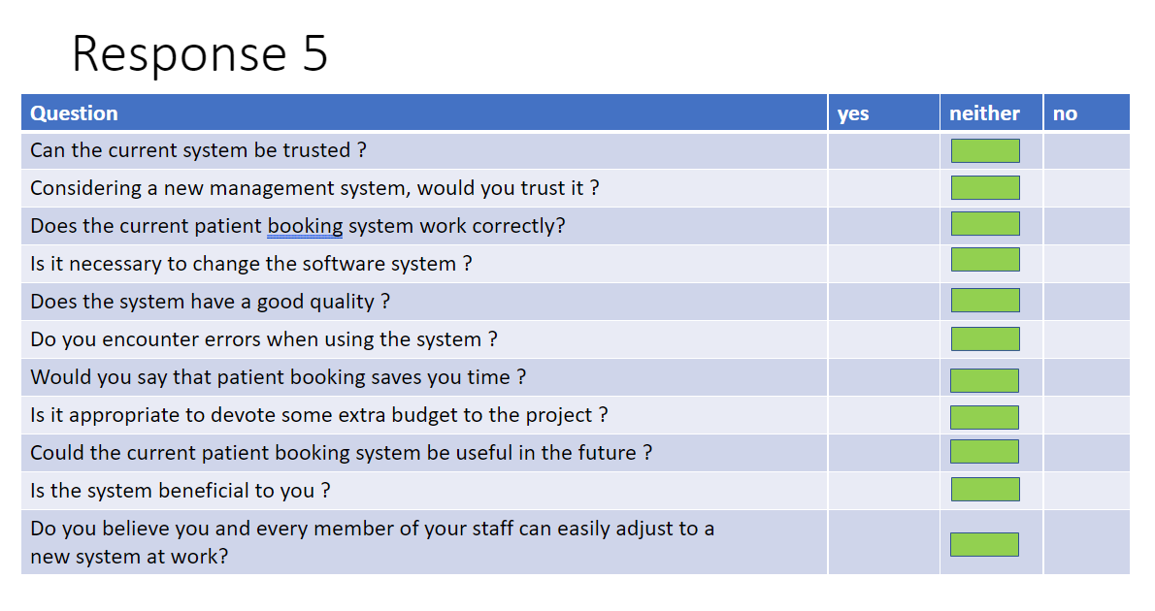

Unexpectedly, this reviewer was neither completely in agreement with the questions nor completely opposed to them.

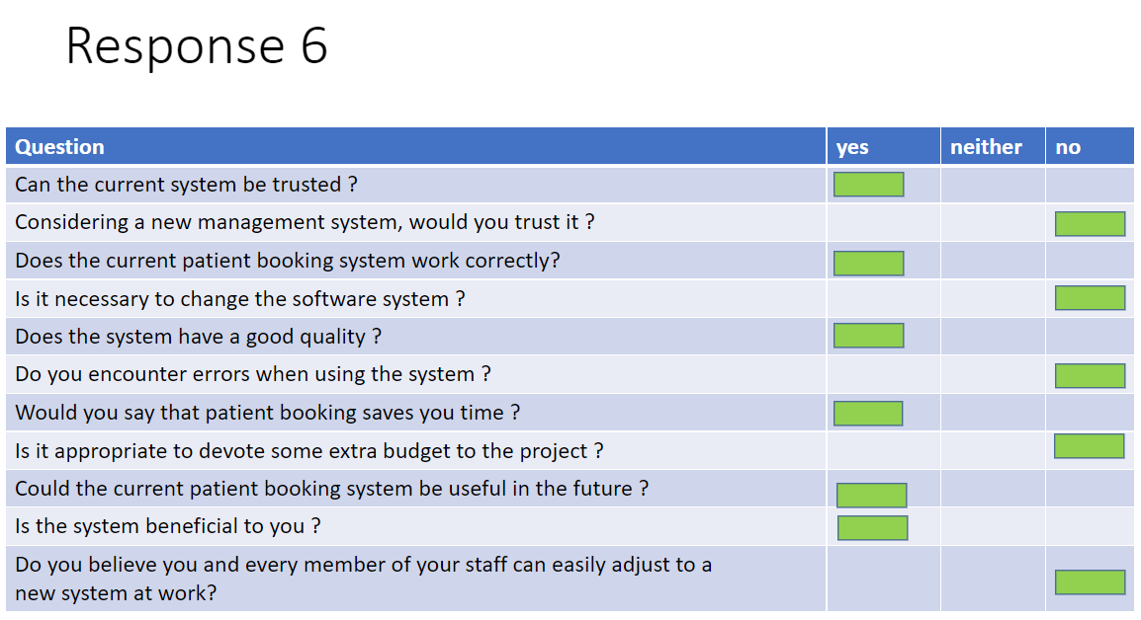

According to this review, the current system has been evaluated favorably. They say that the current system is reliable, works, has excellent quality, saves time, can be used in the future and is beneficial. The dispute was about the fact that staff and patients can easily use a new system as it is trusted, needs change, has errors, needs an extra budget, and is easily understood.

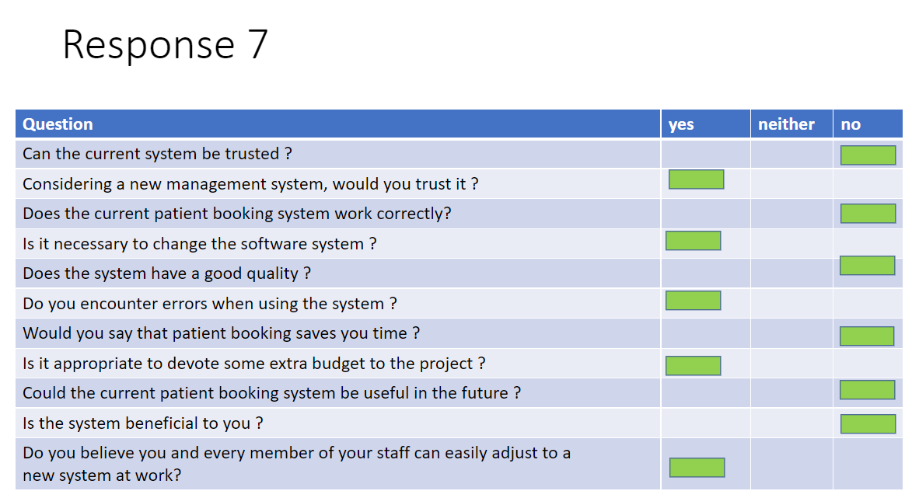

The previous reviewer was highly opposed to this feedback in the reviewer's opinion, the system cannot be trusted, it does not work properly, it does not have superior quality, takes too long, and will not be helpful or beneficial in the future. As opposed to the 6th reply, this reviewer was entirely against the system.

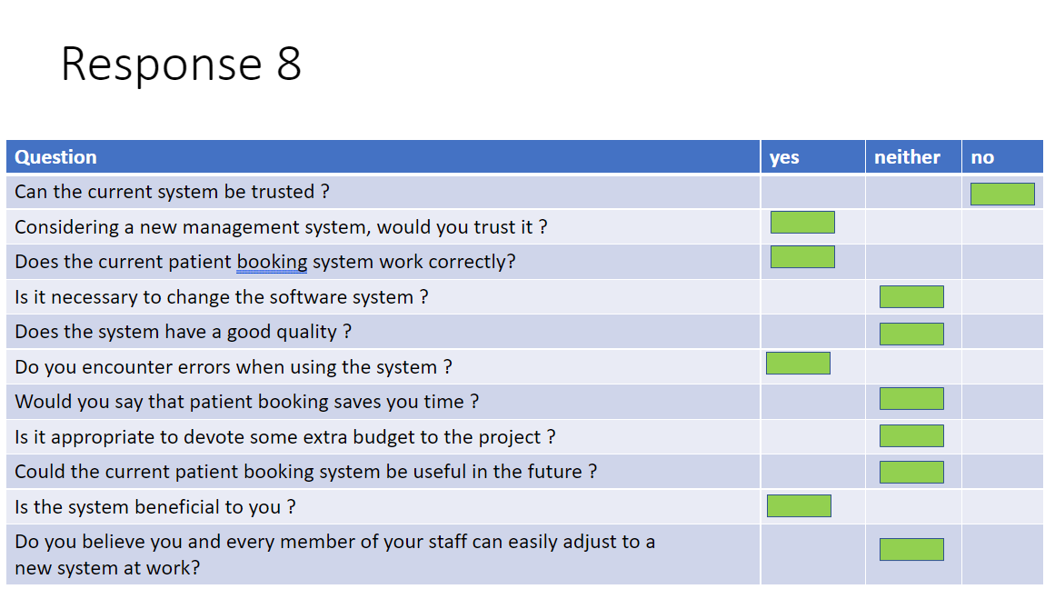

According to the feedback from this individual, they seem to be in a bit of a state of confusion about the system, as most of their questions were not answered. They only answered no to the first question, which was can the current system be trusted. They answered yes to 4/10 of the questions and were unsure about the rest.

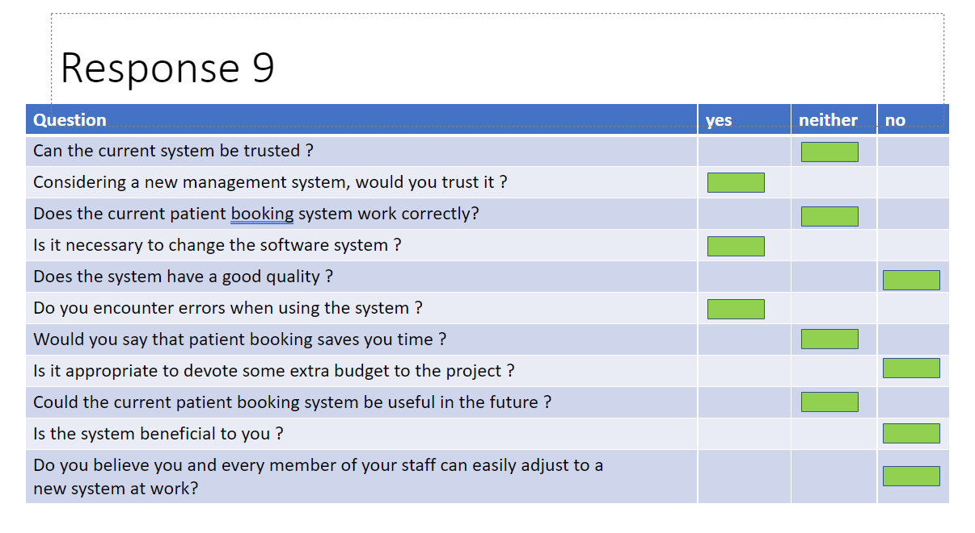

This reviewer was concerned that the new system had errors, would need changes, and that the budget would need to be increased. However, they did not dispute the fact that the system is high quality and has a high budget.

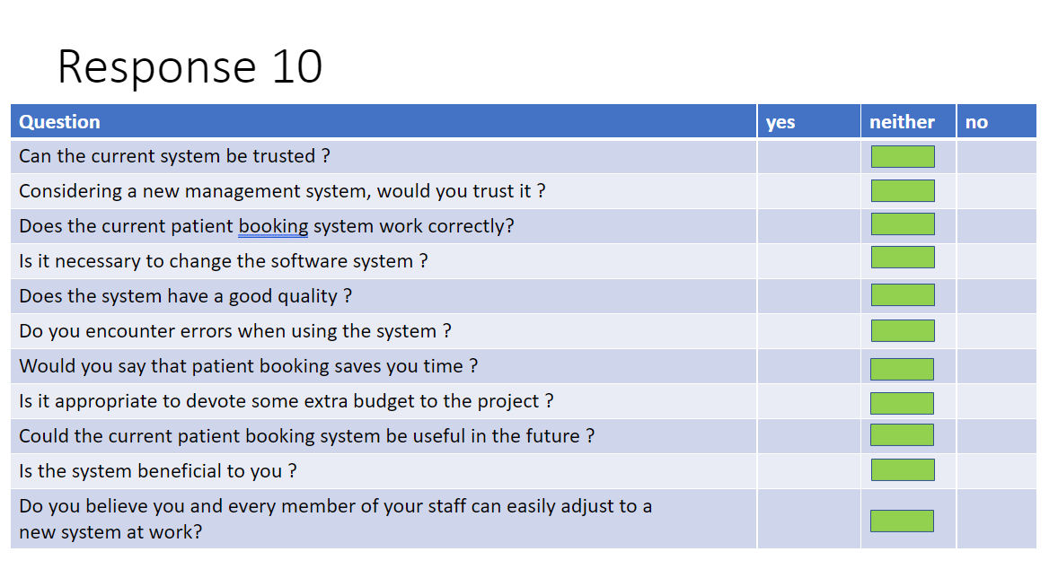

Once again, A very uncertain review is received this time around. This reviewer gave neither a complete agreement nor a total rejection of the questions.

Feedback from the interviews:

**Would it be possible to improve the reliability of the system in light of the fact that many respondents told you that it needs to be improved?**

In my opinion, if many staff members feel that it is bad, then it must have some reliability problems in the system that need to be fixed

**Some staffers have said that they think the system could be updated more frequently. What do you think?**

Updating the system will eliminate the bugs and make the design more modern while also fixing the problems that exist. In some departments, such as the prescription section, the system cannot be outdated.

**In your opinion, why has there been so much feedback that the system needs improvements across the board?**

We need a system that meets a high standard, since we are a hospital. We should make sure the system strives to correct any bugs or issues that may cause confusion for patients and staff.

The methodology that will be used to create the system (M2)

Reason that I am using the waterfall model to create the system:

**Suitability:** Waterfall methods have a focus on the design and development phase rather than the requirements phase, unlike other software development models such as DSDM. As this project has no chance of over announcing, this approach will be the most appropriate.

As opposed to other types of software that may focus on updating and changing that software, the waterfall model provides a better framework for this project, The linear structure of the model ensures that the software used by the hospital staff will never need updating constantly since it is only used by the staff there.

While in the later phases of a waterfall model the client or user cannot provide feedback, suggestions and feedback can be provided to the client/user in the design phase of a waterfall model.

**Universal for project/development team size:**

We designed the waterfall method to work for all team sizes, so small and large companies and development teams will benefit from it equally.

**Development time and cost:** Our goal is to make the project's development process as efficient as possible while adhering to the set budget. In other words, the hospital's specifications are also met as well as the client's. Waterfall modeling is an inexpensive method of handling the cost of a project and keeping it within constraints.

**Errors:** It has been noted that the current system has encountered many errors that have been reported by staff. A frequent error with the system is the creation of two appointments when only one is needed, Because the system does not confirm that appointment information has been saved, the problem is likely to occur. A patient's computer may resend that information if there was a delay between the time the appointment is booked and the arrival at the hospital since confirmation is not received at the time the appointment is booked.

Occasionally, the system would make randomly scheduled appointments that were not scheduled. It was due to the way appointments are organized; currently, patients are differentiated by their names, so if a patient with the same name booked an appointment as another patient, it would sometimes schedule their appointment with that patient.

The errors with the current system would slow down the workflow of staff members due to the errors they would encounter, and this is one of the main reasons why many employees and managers felt the current system needed to be replaced.

**Inaccurate information:** sharing, input, or reading of information from the system database often led to inaccurate results for the staff. Often, they would involve minor errors such as sections being left blank on forms, data being reset, or appointments being scheduled at the wrong time.

**Performance:** There are too many problems with the system, which is associated with the fact that it is outdated and old, thus does not have any new features and has not been improved at all.

**Accessibility:** When there are double bookings or other problems, it is still difficult to understand sometimes as there are still obvious errors with the system.

Recommendations for development:

**User Interface:** Provide each employee with the ability to customize and personalize their system account and interface to suit their needs best. To be able to change the features that some staff do not use in the software, the settings menu could allow them to toggle the features they do not use.

Several staff have suggested more features be added, such as auto-saving notes, appointment reminders sent via email or other platforms that can help staff.

**Errors:** Minor errors with the system can be corrected with minor bug fixes depending on how frequent the errors are, so if the website does not load correctly, the fix will depend on what the error is and its cause.

While there is not one specific error with the system, the type of error and its cause can influence it. For example, the ghost appointment error was caused by the movement of staff and patients. As staff and patients were previously sorted by their names, this could sometimes result in confusion if two or more people had the same name.

Using the current system, ghost appointments could be resolved by assigning ids to each patient or staff member. Since each id is unique, no one else can use that patient's id.

**Inaccurate information:** Several staff members responded to the feedback by stating that the data input and output of the system can be wrongly interpreted or altered, and errors happen when the system contains incorrect information, Data in places such as the database where it must be accurate to function correctly can be affected. Errors like incorrect bookings and patient names can contribute to confusion and delay, which will reduce the quality of the system. Thanks to incorrect dates and incorrect bookings, the system will take longer to complete.

**Performance:** A better and more efficient system can be achieved by updating the system with newer software and frameworks. Additionally, this would mean that there would be fewer bugs and performance problems within the system and that there would be new features added, resulting in better overall performance.

**Accessibility:** It is essential to make the system easy to understand and easier for anyone to navigate through the User Interphase. This can be accomplished by making sure all fonts and colors used are clear and do not mix, thus making it difficult to read.

Design Description

How the system will work:

**Booking appointment via telephone:** To book an appointment with the tameside general hospital, patients can contact the hospital by phone. Once the patients have contacted the hospital, they will be asked for your personal information: date of birth, sex, full name, and address. Following that, the next step would be to choose a time and day from the hospital's availability calendar. Finally, the patient will receive a confirmation text message or a letter that confirms the appointment and serves as a reminder.

**Booking appointment via text/website:** To schedule an appointment via text, you will be redirected to a website where you will be required to provide the following information: date of birth, gender, complete name, and address. They can then choose an available time. This is the same for those who want to create an appointment through the website.

**Staff booking an appointment for patients:** In addition to arranging appointments, staff can also book appointments by phone or in person for the patients. To complete the process, they will need a patient's personal information, which includes their date of birth, gender, name, and address. A staff member may then ask for a time and date when an appointment is available

**How appointment confirmation letters are sent out:** A confirmation letter is mailed to the patient's address provided during the appointment creation process once his/her appointment has been successfully booked. The purpose of this letter will be to remind the patient that they have a guaranteed appointment, as well as to remind them that they can change the appointment time or date as needed. For any reason the person might need to change their appointment time or day, they will receive a confirmation code that can be applied to the website or expressed to the staff via a phone call, and that code can be used to change their appointment.

**When a GP books an appointment:** Whenever a patient seeks an appointment with their doctor, they should first let them know how they feel. The gp will ask for the patient's name and address. They will then be escorted by a staff member when it is their turn.

**When a patient makes an appointment:** patients can also book their own appointments at their gp. To do this they simple have to fill in some information which includes: name, address, data of birth and reason for medical help.

**What automated reminders for patients' function:** patients can receive reminders in several ways. A few common preferred methods are: text messages, emails, letters, and phone calls.

**Arriving at appointment: (sign in)** When your appointment is due, you will need to make your way to the receptionist who will confirm your appointment. To do this, they will read or ask you for the following information: phone number, address, name, and date of birth.

**Appointment procedure:** After the receptionist has confirmed your appointment, they will give you a number and ask you to wait in the waiting room for your appointment. This number represents the queue.

Description of user interface:

**Patient Details:** for the patients, their user interface will be very simple. We have chosen to keep it simple so that it will be quick and save time. For the patients, they will be redirected to a page where they can put in their detail and access their account. Once they have access to their account they can then check if they have any due appointments, and they have the option to book appointments.

**New Staff Member Details:** For the new staff who are working at the tameside general hospital, they also must sign up. In order to sign up, they must fill in an online application asking for the following information, email, password, name, date of birth, address and gender

Potential constraints of the design

Risks with designing the new system:

* The project can be seen as unrealistically planned.
* There is no adequate time to study, design, plan, test and execute the change, and the project is poorly managed.
* Overspend and delay the project

**Completing tasks within deadlines:** It is possible that the main goals set within a timeframe can be missed when developing the new system with all the features and requirements specified, which can cause other deadlines to be missed as well.

**Budget**: To minimize the risk of overspending, the development team must set a budget that minimizes the risk of unexpected events or changes to the system. By planning carefully and sticking to your plan, you can minimize this risk.

**Constraints of the new system:**

**Costs:** To ensure we cover all risks; we might need to slightly increase our budget with the new development. This time we will increase our budget and make sure we cover more areas which need improvements.

**Time:** As we move forward with the new system, we will take our time and use it wisely to create a better system for our staff and patients.